Eaves Primary School

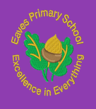

PSHE Policy
Written by: | Mrs L. Ward | Date: June 2021
Approved by: | Governors | Date: 14.6.21
Last reviewed: | June 2020
Next review due by: | June 2023
Date shared with parents: | 14.7.21

- Purpose of the PSHE Policy

Aims & Objectives
The aims of this policy are:
- To set out the expectations of PSHE within Eaves Primary school.
- To outline how PSHE will be delivered across the school.
- To ensure that all members of the school community understand how we support our children in becoming valued members of society.
Personal, Social, Health and Economic Education (PSHE) should enable children to become healthy, independent and responsible members of society. As a school, we will use the statutory content within the National Curriculum and from other statutory guidance on: drug education, financial education, sex and relationship education (SRE) and the importance of physical activity and diet for a healthy lifestyle.
At Eaves, we encourage our pupils to play an active and positive role in contributing to the life of the school and its wider community. Through doing this, we help develop children’s independence, responsibility and help create a strong sense of self-worth.
The aims of PSHE are to enable the children to:
- know and understand what constitutes a healthy lifestyle;
- be aware of safety issues and to have an active voice;
- understand what makes for good relationships with others and identify a negative relationship;
- have respect for themselves and others;
- be independent and responsible members of the school and wider community;
- be positive and active citizens of a democratic society;
- develop self-confidence and self-esteem and make informed choices regarding personal and social issues;
- develop good relationships with other members of the school and the wider community;
- make the most of their ability.

- Links to other policies and curriculum areas

- SRE, PE and Science policies - link with Personal and Health Education strands.
- Behaviour policy - links with citizenship/social education.
- Equal Opportunities policy - links with the Personal and Social Education strands.
- Health and Safety Policy - links with the Health Education strand.

- Definition of PSHE

PSHE education addresses both pupils’ current experiences and preparation for their future. Our thematic study approach provides a spiral curriculum in which our pupils develop their knowledge, skills and attributes. A place where prior learning is revisited, reinforced and extended year on year. This is grounded in the established evidence base for effective practice in PSHE education at Eaves

- How we teach PSHE at Eaves Primary School?

Teaching and learning
At Eaves we use a range of teaching and learning styles with an emphasis on active learning by including the children in discussions, investigations and problem-solving activities. We believe it is vital to bring the curriculum alive and really challenge our children to often step outside of their comfort zone in a supportive and trust driven environment. In doing so we aim to provide them with in-depth knowledge to give them an active and confident voice. PSHE is at the heart of all we do at Eaves as research shows the positive impact of an effective PSHE curriculum on pupil attainment and positive outcomes for learners.

PSHE will be taught in a variety of ways, to reflect the age of the pupils and ensure a whole school approach to the subject:

- There will be a regular planned weekly session in which rules will be clearly established and reinforced at the start of every session – sign of mutual respect and trust.
- Each planned session will use baseline and end point assessments.
- During these sessions, pupils regularly work with learning partners or in groups, facilitating respect, cooperation, fairness, sharing and negotiation. Through talk time sessions, pupils are also encouraged to participate in discussion to resolve conflicts or set agreed classroom rules or behaviour.
- There will be a huge emphasis of the spoken word during these sessions – developing confident communicators is key.
- Our culture capital is a way in which our curriculum is brought to life through the use of visitors, such as health workers, police, and representatives from St Nicolas’ parish, whom we invite into the school to talk about their role in creating a positive and supportive community.

Early Years Foundation Stage
Personal, Social and Emotional Education is seamlessly woven into all areas of our early years philosophy and it also is one of the three prime areas. We teach PSHE and citizenship as an integral part of the topic work covered during the year through the Early Learning Goals (ELGs). All areas of learning are important and inter-connected; however, PSE is vital for building their capacity to learn, form relationships and thrive. This is a firm building block in creating confident, independent and active learners.
The EYFS Framework states that: Personal, social and emotional development involves helping children to develop a positive sense of themselves, and others; to form positive relationships and develop respect for others; to develop social skills and learn how to manage their feelings; to understand appropriate behaviour in groups; and to have confidence in their own abilities.

Assessment and Recording:
- PSHE education covers issues and areas of life which children and young people will be affected by in different ways and at different times. As such we cannot make any assumptions based on pupils’ age or year group about their existing knowledge, understanding, attributes, skills, strategies, beliefs and attitudes. In order to assess learning and progress effectively, it is important to carry out a baseline assessment before teaching anything new. As pupils’ learning of topics will come from a number of sources, we can only see whether they have made progress in their learning if we have established the knowledge, understanding, attributes, skills, strategies, beliefs and attitudes they had before any new teaching took place. This baseline assessment is key to identifying the correct starting point and to note the progress made.
Baseline assessment strategies
Assessment tool | Most effective for assessing…
Questioning | Knowledge, understanding, attitudes, beliefs, strategies, pupils’ questions relating to the topic
Discussing | Knowledge, understanding, attitudes, beliefs, strategies, pupils’ questions relating to the topic
Brainstorming | Knowledge, understanding, attitudes, beliefs
Drama – role play, hot seating, freeze frame and other drama activities | Skills, strategies, attitudes
Story boards, writing, script writing, drawing | Skills, strategies, attitudes
Mind-map | Knowledge, understanding, attitudes, beliefs
Continuums | Attitudes, beliefs, attributes
Self-assessment tools – scales etc | Attitudes, beliefs, attributes
Explanation activity – explain to someone else | Knowledge, understanding, attitudes, beliefs, strategies, complex concepts
Responding to a scenario, picture or video clip | Knowledge, understanding, attitudes, beliefs, strategies

Here are some additional ideas in which assessments can be carried out;
presentations, producing resources and materials to teach younger pupils, leading a discussion or other learning activity with younger pupils, producing a blog or podcast, keeping a journal, diary or log of times when they have demonstrated a particular skill or attribute during the week.

Assessing progress
Baseline assessment | End point activity to demonstrate progress
Questioning | Revisit key questions, extending with higher order questions. Invite pupils to think of key questions for future learning
Discussing | Revisit main arguments from baseline discussion; formal debate; presentations.
Brainstorming | If written down, revisit in a different colour – add, amend, expand
Drama – role play, hot seating, freeze frame and other drama activities | Repeat activity, showing how strategies have developed/changed and demonstrating new skills; script a conversation or role-play on a related but more challenging situation
Story boards, writing, script writing, drawing | Evaluate effectiveness of baseline strategies/ideas through discussion; revisit in a different colour – add, amend, expand, change; role-play their revised script.
Mind-map | Revisit in a different colour – add, amend, expand.
Continuums | Repeat the activity, asking pupils to discuss whether- and if so how far- they have moved along the continuum and why; photograph new continuum or washing line positions and compare with photo of baseline positions.
Self-assessment tools – scales etc | Pupils rate themselves on the same scale in the light of the new learning.
Explanation activity – explain to someone else | Revisit in a different colour – add, amend, expand; think of additional questions for the alien to ask to explore the concept further and answer each other’s questions.
Responding to a scenario, picture or video clip | If written down, revisit in a different colour – add, amend, expand; discuss or write down any changes to their response as a result of the learning.

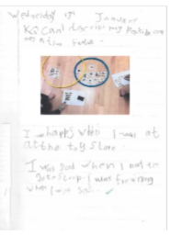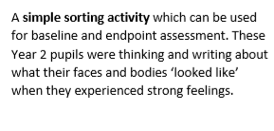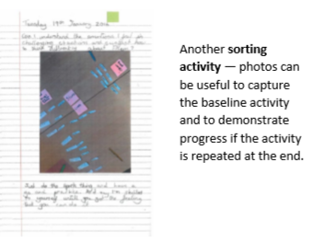

- Content and Organisation of the Programme

Our PSHE curriculum is built around a thematic approach allowing the children to keep bubbling and extending their knowledge and skills around the themes of relationships, living in the wider world and health and wellbeing. Discreet PSHE sessions are planned within the weekly timetable and are fused around continuity, progression and meaningful assessments. We aim to give our children the knowledge and skills to access the ever changing and demanding world around them. Our curriculum is active and never static and will remain as a working document that will evolve with the needs of our children, community and wider world.
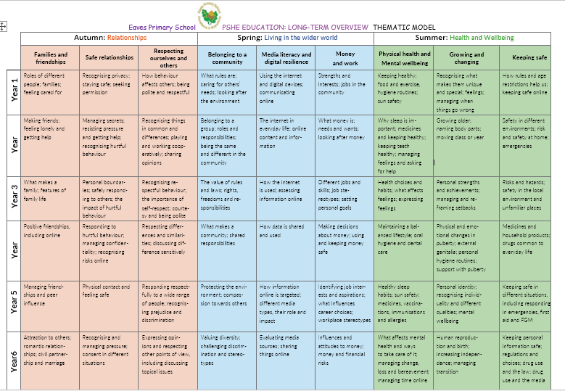

- PSHE Across the Curriculum
Across school the philosophy of our PSHE curriculum is imbedded in the way that we approach all aspects of school life including taking on responsibilities in the classroom, JRSO’s, school councillors, play ground leaders, Eaves Ears, Year 6 Buddies, Maths and Science ambassadors and representing school in the wider community. We are always striving to be outstanding citizens of the future and our PSHE curriculum gives us the tools and the voice to do so. PSHE is woven into all subjects and teachers will use cross curricular links to enhance the meaning and develop a topic further. We also ensure that children have the knowledge to question and challenge in line with their own knowledge and skill development. For example, in English sessions children may be encouraged to identify serotyping and explore how that impacts on the reader.

Inclusion
At Eaves Primary school we teach PSHE and Citizenship to all children, whatever their ability. PSHE and Citizenship form part of the school curriculum policy to provide a broad and balanced education for all children. Through our PSHE and Citizenship teaching we provide learning opportunities that enable all pupils to make progress by setting suitable learning challenges and responding to differing needs. Activities and debates challenge our most able pupils to formulate personal views based on evidence they research and discuss.
- Monitoring and Review

The PSHE team and lead are responsible for monitoring the standards of children’s work and the quality of teaching through book looks and through gaining the voice of the child. By doing this, they can evaluate strengths and areas to develop in order to ensure that this curriculum is ever evolving just like the world around us.

This policy is monitored by the Governing Body and will be reviewed in three years or earlier if necessary.

Appendix
Curriculum
Relationships – Statutory
By the end of primary school:
Families and people who care for me
Pupils should know • that families are important for children growing up because they can give love, security and stability.
• the characteristics of healthy family life, commitment to each other, including in times of difficulty, protection and care for children and other family members, the importance of spending time together and sharing each other’s lives.
• that others’ families, either in school or in the wider world, sometimes look different from their family, but that they should respect those differences and know that other children’s families are also characterised by love and care.
• that stable, caring relationships, which may be of different types, are at the heart of happy families, and are important for children’s security as they grow up.
• that marriage represents a formal and legally recognised commitment of two people to each other which is intended to be lifelong.
• how to recognise if family relationships are making them feel unhappy or unsafe, and how to seek help or advice from others if needed.
Caring friendships
Pupils should know • how important friendships are in making us feel happy and secure, and how people choose and make friends.
• the characteristics of friendships, including mutual respect, truthfulness, trustworthiness, loyalty, kindness, generosity, trust, sharing interests and experiences and support with problems and difficulties.
• that healthy friendships are positive and welcoming towards others, and do not make others feel lonely or excluded.
• that most friendships have ups and downs, and that these can often be worked through so that the friendship is repaired or even strengthened, and that resorting to violence is never right.
• how to recognise who to trust and who not to trust, how to judge when a friendship is making them feel unhappy or uncomfortable, managing conflict, how to manage these situations and how to seek help or advice from others, if needed.
Respectful relationships
Pupils should know • the importance of respecting others, even when they are very different from them (for example, physically, in character, personality or backgrounds), or make different choices or have different preferences or beliefs.
• practical steps they can take in a range of different contexts to improve or support respectful relationships.
• the conventions of courtesy and manners.
• the importance of self-respect and how this links to their own happiness.
• that in school and in wider society they can expect to be treated with respect by others, and that in turn they should show due respect to others, including those in positions of authority.
• about different types of bullying (including cyberbullying), the impact of bullying, responsibilities of bystanders (primarily reporting bullying to an adult) and how to get help.
• what a stereotype is, and how stereotypes can be unfair, negative or destructive.
• the importance of permission-seeking and giving in relationships with friends, peers and adults.
Online relationships
Pupils should know • that people sometimes behave differently online, including by pretending to be someone they are not.
• that the same principles apply to online relationships as to face-to-face relationships, including the importance of respect for others online including when we are anonymous.
• the rules and principles for keeping safe online, how to recognise risks, harmful content and contact, and how to report them.
• how to critically consider their online friendships and sources of information including awareness of the risks associated with people they have never met.
• how information and data is shared and used online.
Being safe
Pupils should know • what sorts of boundaries are appropriate in friendships with peers and others (including in a digital context).
• about the concept of privacy and the implications of it for both children and adults; including that it is not always right to keep secrets if they relate to being safe.
• that each person’s body belongs to them, and the differences between appropriate and inappropriate or unsafe physical, and other, contact.
• how to respond safely and appropriately to adults they may encounter (in all contexts, including online) whom they do not know.
• how to recognise and report feelings of being unsafe or feeling bad about any adult.
• how to ask for advice or help for themselves or others, and to keep trying until they are heard.
• how to report concerns or abuse, and the vocabulary and confidence needed to do so.
• where to get advice e.g. family, school and/or other sources.
Physical Health and Mental Well-Being - Statutory
Mental wellbeing
Pupils should know • that mental wellbeing is a normal part of daily life, in the same way as physical health.
• that there is a normal range of emotions (e.g. happiness, sadness, anger, fear, surprise, nervousness) and scale of emotions that all humans experience in relation to different experiences and situations.
• how to recognise and talk about their emotions, including having a varied vocabulary of words to use when talking about their own and others’ feelings.
• how to judge whether what they are feeling and how they are behaving is appropriate and proportionate.
• the benefits of physical exercise, time outdoors, community participation, voluntary and service-based activity on mental wellbeing and happiness.
• simple self-care techniques, including the importance of rest, time spent with friends and family and the benefits of hobbies and interests.
• isolation and loneliness can affect children and that it is very important for children to discuss their feelings with an adult and seek support.
• that bullying (including cyberbullying) has a negative and often lasting impact on mental wellbeing.
• where and how to seek support (including recognising the triggers for seeking support), including whom in school they should speak to if they are worried about their own or someone else’s mental wellbeing or ability to control their emotions (including issues arising online).
• it is common for people to experience mental ill health. For many people who do, the problems can be resolved if the right support is made available, especially if accessed early enough.
Internet safety and harms
Pupils should know • that for most people the internet is an integral part of life and has many benefits.
• about the benefits of rationing time spent online, the risks of excessive time spent on electronic devices and the impact of positive and negative content online on their own and others’ mental and physical wellbeing.
• how to consider the effect of their online actions on others and know how to recognise and display respectful behaviour online and the importance of keeping personal information private.
• why social media, some computer games and online gaming, for example, are age restricted.
• that the internet can also be a negative place where online abuse, trolling, bullying and harassment can take place, which can have a negative impact on mental health.
• how to be a discerning consumer of information online including understanding that information, including that from search engines, is ranked, selected and targeted.
• where and how to report concerns and get support with issues online.
Physical health and fitness
Pupils should know • the characteristics and mental and physical benefits of an active lifestyle.
• the importance of building regular exercise into daily and weekly routines and how to achieve this; for example walking or cycling to school, a daily active mile or other forms of regular, vigorous exercise.
• the risks associated with an inactive lifestyle (including obesity).
• how and when to seek support including which adults to speak to in school if they are worried about their health.
Healthy eating
Pupils should know • what constitutes a healthy diet (including understanding calories and other nutritional content).
• the principles of planning and preparing a range of healthy meals.
• the characteristics of a poor diet and risks associated with unhealthy eating (including, for example, obesity and tooth decay) and other behaviours (e.g. the impact of alcohol on diet or health).
Drugs, alcohol and tobacco
Pupils should know • the facts about legal and illegal harmful substances and associated risks, including smoking, alcohol use and drug-taking.
Health and prevention
Pupils should know • how to recognise early signs of physical illness, such as weight loss, or unexplained changes to the body.
• about safe and unsafe exposure to the sun, and how to reduce the risk of sun damage, including skin cancer.
• the importance of sufficient good quality sleep for good health and that a lack of sleep can affect weight, mood and ability to learn.
• about dental health and the benefits of good oral hygiene and dental flossing, including regular check-ups at the dentist.
• about personal hygiene and germs including bacteria, viruses, how they are spread and treated, and the importance of handwashing.
• the facts and science relating to allergies, immunisation and vaccination.
Basic first aid
Pupils should know: • how to make a clear and efficient call to emergency services if necessary. • concepts of basic first-aid, for example dealing with common injuries, including head injuries.
Changing adolescent body
Pupils should know: • key facts about puberty and the changing adolescent body, particularly from age 9 through to age 11, including physical and emotional changes.
• about menstrual wellbeing including the key facts about the menstrual cycle.

