Eaves Primary School
‘Excellence in Everything’

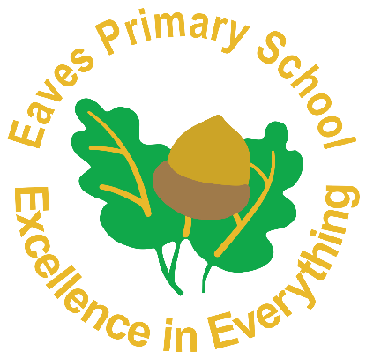

Healthy Lunchbox and Snack Policy

May 2021
Status | Non-Statutory
Responsible Governors’ Committee | Resources
Responsible Person | Mrs N Kearney
Review Date | May 2023
Last amended | July 2019

At Eaves Primary School we aim to educate our children with the skills, knowledge and understanding to enable them to make informed healthy lifestyle choices. To do that effectively we need to work in partnership with parents and carers in securing the best for every child.
22

Aims
• To ensure children have a suitable midday meal that sustains and prepares them for the afternoon learning,
• To provide a safe, healthy and appealing eating environment for pupils bringing in packed lunches and ensure that free, fresh drinking water is available at all times,
• To help children develop an understanding of healthy eating,
• To promote the School Food Trust guidelines and national standards for healthier eating,
• To support parents and carers in providing a healthy packed lunch that meets the same standards as food provided in school dinners and abide by the regulations of the British Nutrition Foundation.
Guidelines
The following guidelines for lunchbox contents comes from the statutory guidelines for school provided meals. This ensures equality of entitlement for all children.
The recommended contents of a healthy lunch box are:
• A good portion of starchy food e.g. bread, crackers, pasta or rice salad,
• Plenty of fruit and vegetables e.g. an apple, orange, banana, carrot sticks, small box of raisins or any other fruit or vegetable,
• A portion of milk or dairy food e.g. yoghurt, cheese string
• A drink e.g. a small carton of milk, juice, squash or a bottle of water,
• One small biscuit e.g. kit-kat, penguin, club, fun-size chocolate bar, cake bar etc. – This is equivalent to a school meal dessert.
PLEASE TRY TO AVOID SENDING YOUR CHILD WITH NUTS OR FOOD CONTAINING NUTS AS WE HAVE A NUMBER OF CHILDREN WITH ALLERGIES.
Packed lunches must not include:
• Full size/large chocolate bars or sweets,
• Fizzy/energy drinks.
PLEASE PROVIDE APPROPRIATE SIZED SNACKS (NOT GRAB BAGS/FAMILY BAGS/SHARE BAGS), PARTICULARY FOR TRIPS.

Monitoring and Evaluation
We fully respect individual parent’s food choices for their children and understand that there are many different needs and tastes. However, if lunchbox contents regularly fall short of the expectations in this policy we will send a reminder home to parents. We want to work with parents to educate our children about healthy dietary choices so that the children, through the understanding of a balanced diet, will develop a greater appreciation of a healthy lifestyle.
Healthy Snacks
All children in KS1 and Reception receive a free piece of fruit or vegetable everyday as part of the Government’s School Fruit and Vegetable Scheme. As children move up into KS2, if they wish to have a break time snack, they are required to bring in something from home.
Healthy snacks can include:
• Fruit,
• Vegetables,
• Dried fruits,
• Dairy product (Yogurt, cheese string)
• Bread product (bagel, brioche, breadsticks)
• Crackers, rice crackers
• Fruit/malt loaf
PLEASE DO NOT SEND YOUR CHILD WITH CEREAL BARS, CRISPS, CHOCOLATE OR SWEETS
Dissemination of the Policy
The policy will be available on the school’s website and will be incorporated into the school prospectus, assemblies etc. The school will use opportunities such as new parents’ meetings and Healthy Lifestyle weeks to promote this policy as part of a whole school approach to healthier eating. All school staff, including; teaching, pastoral, catering staff, will be informed of this policy and will support its implementation. To be implemented from September 2019. Reviewed bi-annually.

This policy was adopted at the Resources sub-committee meeting on 24th May 2021.

